22nd December 2023

This is the season to sparkle and shine!
As the year ends, we wanted to take a moment to spread some holiday cheer and express our gratitude for each and every one of you who make our club a vibrant and wonderful place.

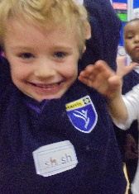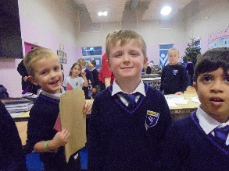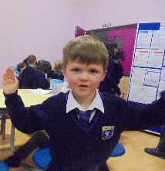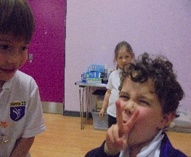
We have spent the most of December joining in, with Christmas activities and crafts. We also had some special guests join us for a visit. Two lovely alpacas named Truffle and Caramel came to visit the club, all the children got to meet them and feed them carrots!
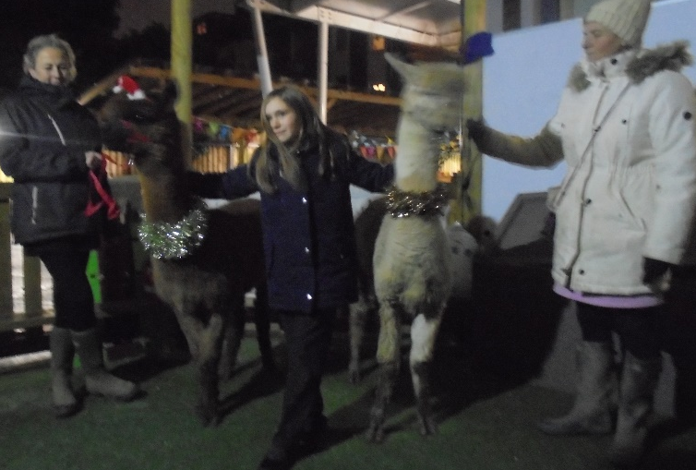

The children and staff have had a very busy term and are excited to share some highlights with you.

Highlights:

Table 1:
The sound of music has filled the air, Table one has enjoyed the instruments this term especially the xylophone!
They have participated in some exciting science, making a bicarb and vinegar reaction, and making some raisins dance.
Lots of Christmas colouring and decorations have been made this term. including cards and a tasty baked treat to end the term.

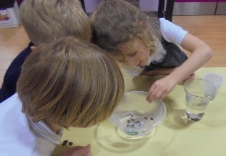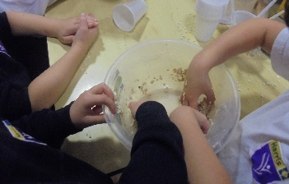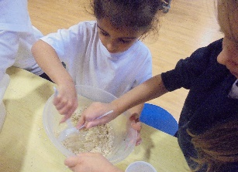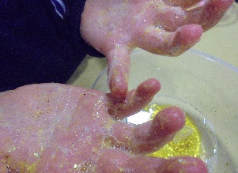

Table 2:
Table two have enjoyed making playdough together creating lots of pretend food to share. The children have enjoyed learning new games like dominoes and getting more skilled at chess. Table two have embarked on some nature investigations, they used magnifying glasses to get a closer look at some autumn leaves, pinecones, and mini beasts. They then discussed this with each other and drew what they could see.
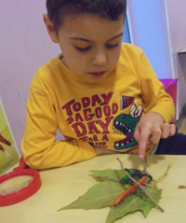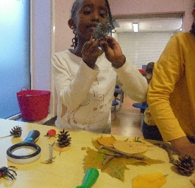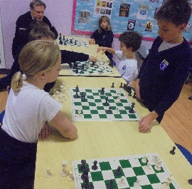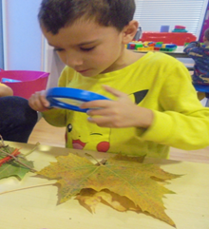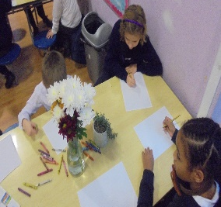

Table 3:
Table three love to be artsy and have done lots of junk modelling, making games and fashion out of boxes and containers.
The children have been doing some Christmas activities, including colouring and and puzzle sheets. Some lovely Christmas cards
were made, the children added a small ornament to their cards and was very excited about this, The children enjoyed their Christmas baking and decorating.

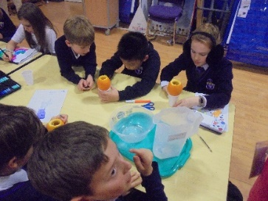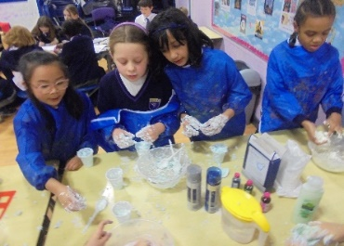

Table 4:
The children on table 4 have had a busy term. starting with some very sparkly firework paintings using toilet rolls as stamps. we have decorated some biscuits with poppies for Remembrance Day, and made paper ones to wear also.
In December the children got to pick a activity out of their calendar every day, we really enjoyed, making paper chains, wreaths and Gingerbread men. (That turned out to be clinamen men) The favourite of the term was the blindfolded taste test, where children were given a different variety of food and see if they could guess them.

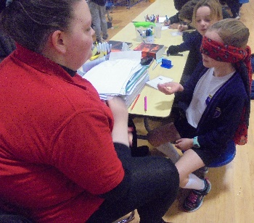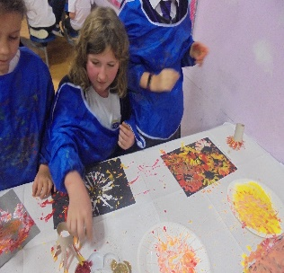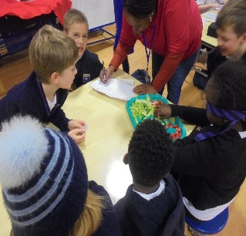

Table 5:

Table five enjoyed junk modelling this term and have since continued a project over the last couple weeks to complete a puppet stage out of a cardboard box, even including fairy lights.
The children have joined in with table four often, decorating biscuits for Remembrance Day and making Christmas decorations.
The hall smelt amazing when the children made colourful volcanoes in lemons, using bicarb and vinegar.

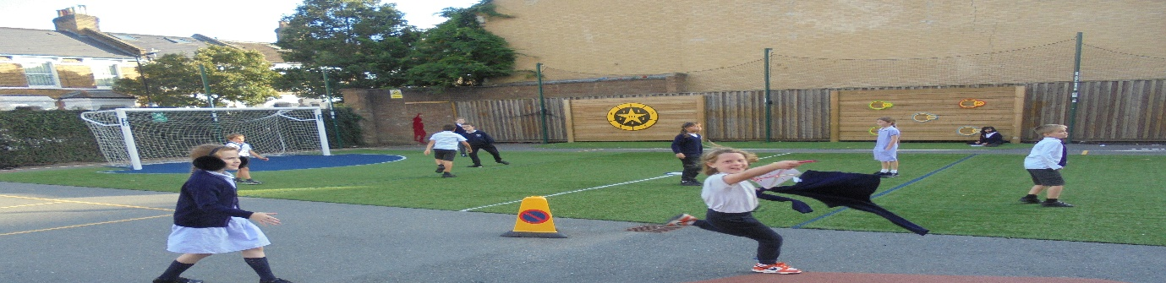

Happy Holidays from all the staff at early bloomers!

Club Director: Tal Kaur | Enquiries: 07742 213056 | Email: admin@earlybloomers.co.uk
Website: earlybloomers.co.uk

